**Electrical Design**



***Objectives***

* **Reliability**
* **Data acquisition**
* **User-friendly**

***Conception steps***

* [**Requirements analysis**](https://www.linguee.fr/anglais-francais/traduction/requirements+analysis.html) : Rules, information on the dashboard, data acquisition, gearshift solution.
* **Distribution of task**: choice to buy a data logger.
* **Choice of the buy elements**: ECU data logger, gear shifter.

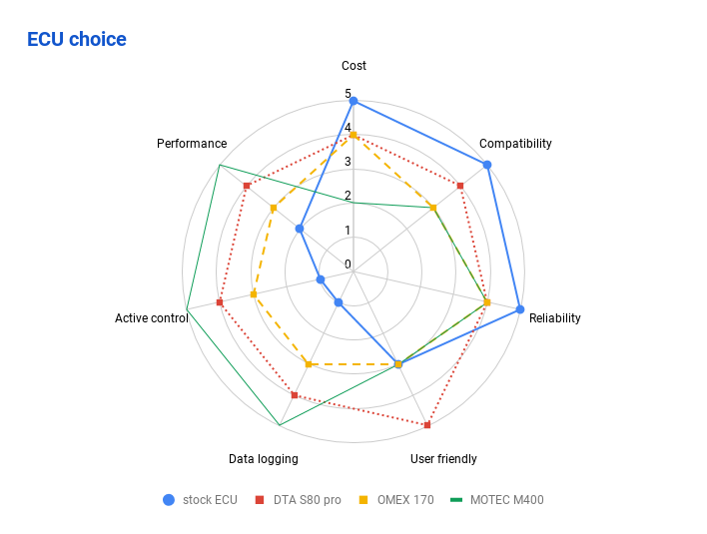

* Construction of the **architecture diagram** 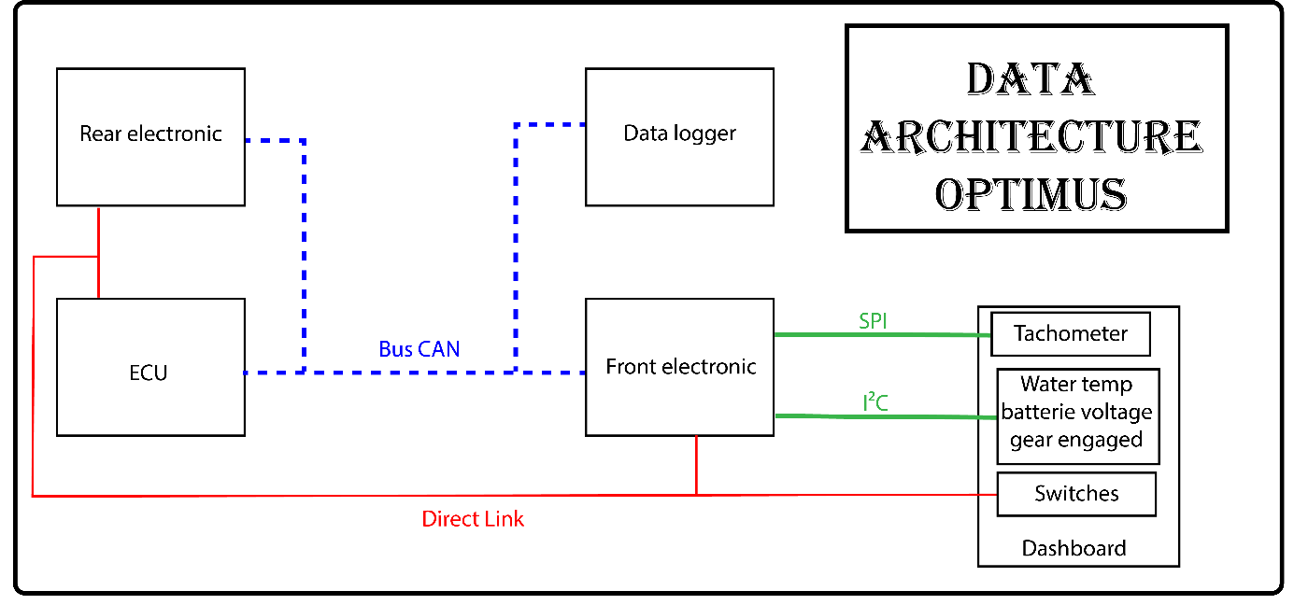
* Drawing of the **electrical harness**

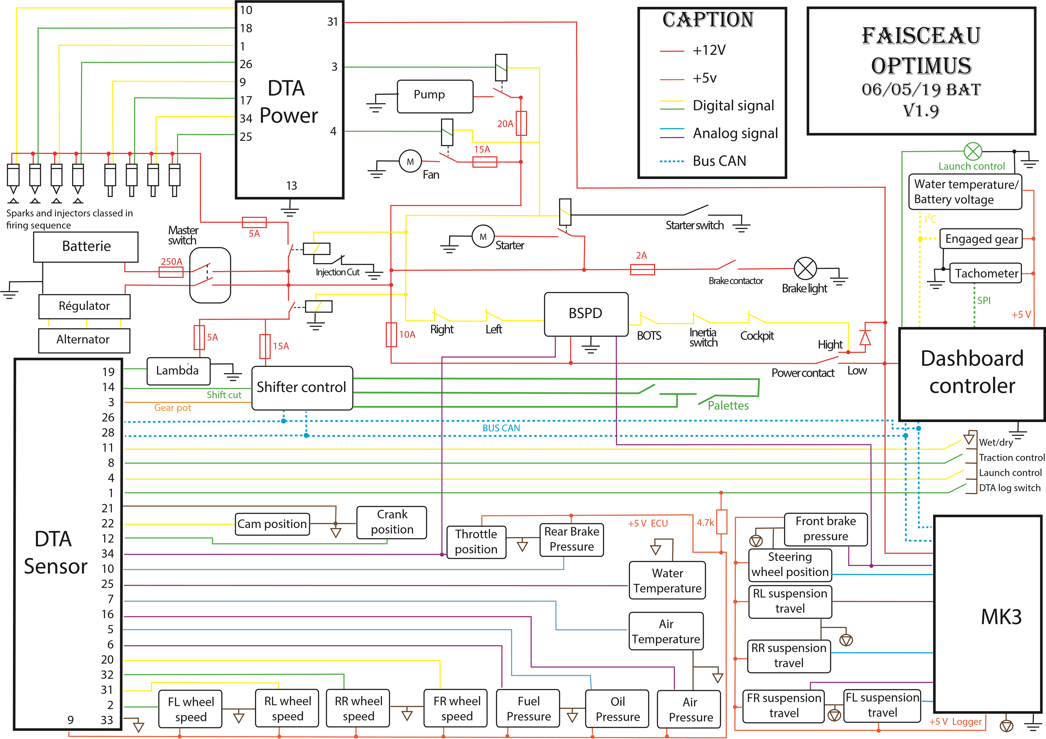

* **Design of the electronics circuits** 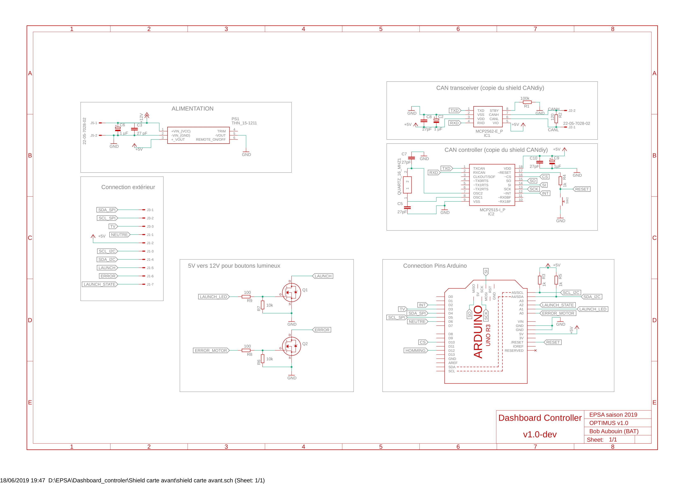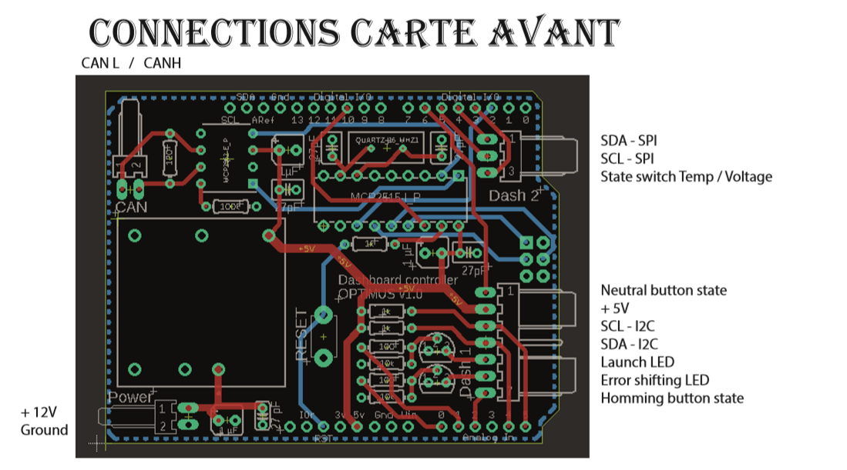
* Drawing of a **2D plan** of the electrical harness on the car

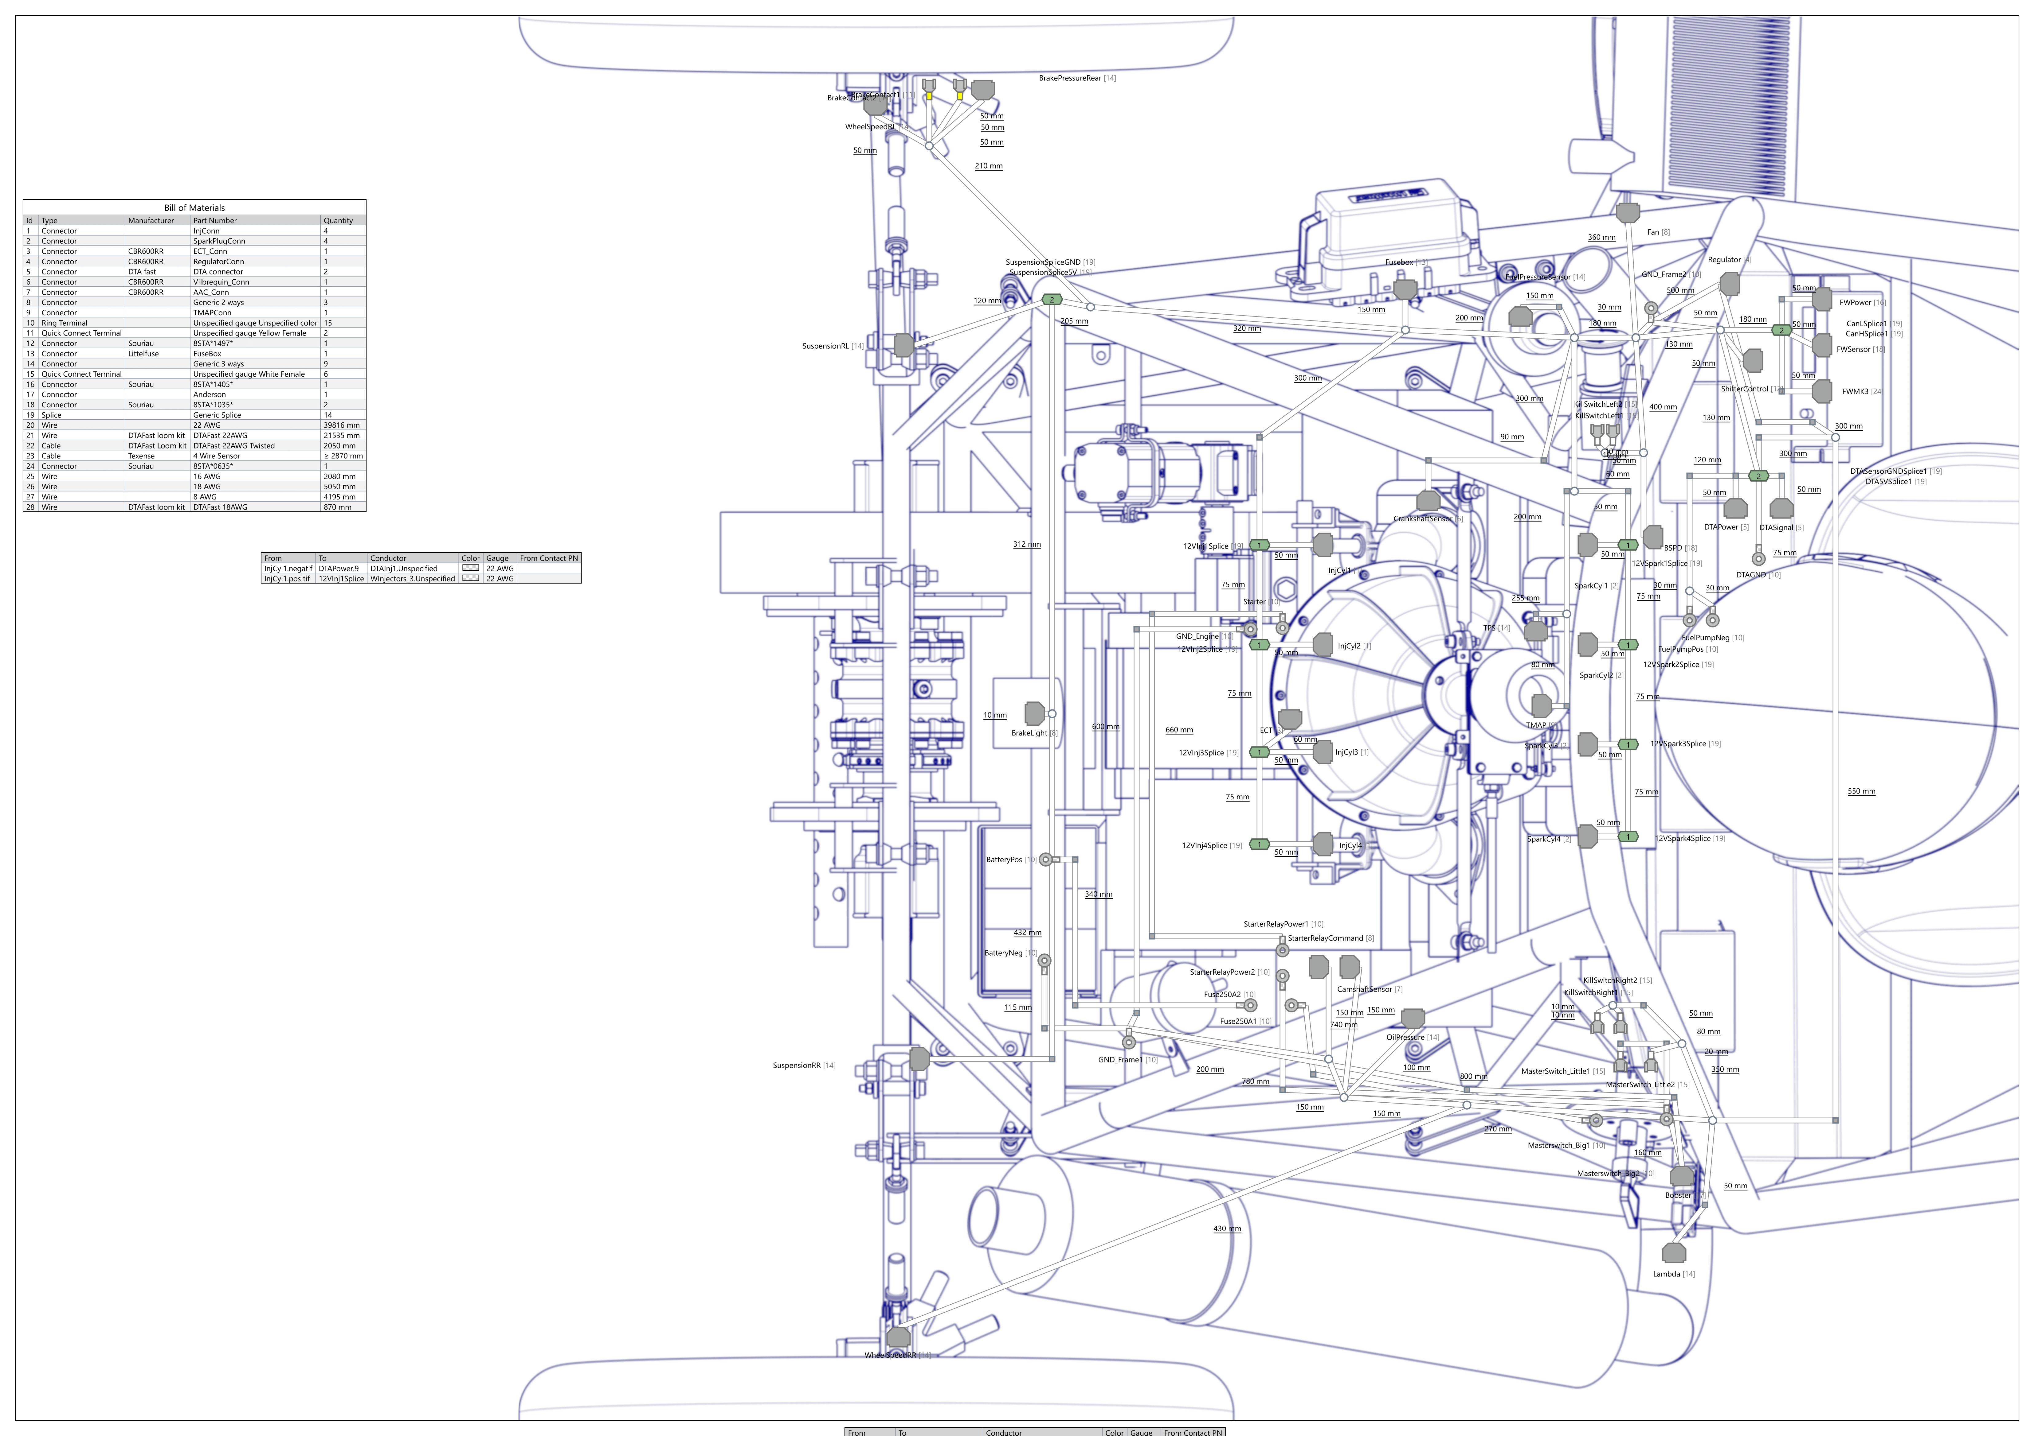

* **Programming** of the 2 Arduino for dashboard display and gear changes in parallel with the previous step *\*A graphset for gearshift?\**

***Manufacturing Process***

* We first **solder** our component on the PCB and put them into their boxes.

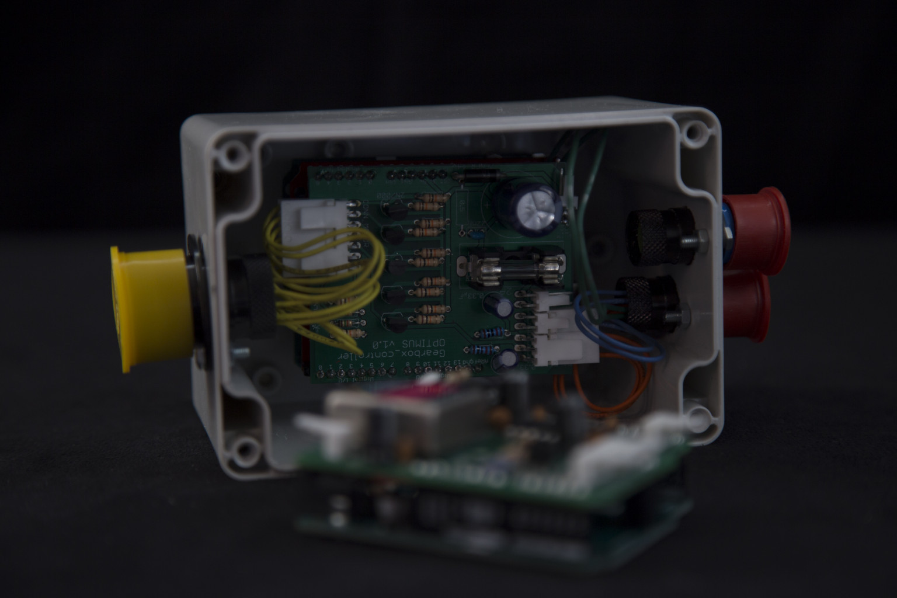

* We use a **rope** to make the **skeleton** of the electrical harness and we put it on the frame to get the **real length** of our cable.
* Next, we use a **board** to put all the wire together following our 2D plan.

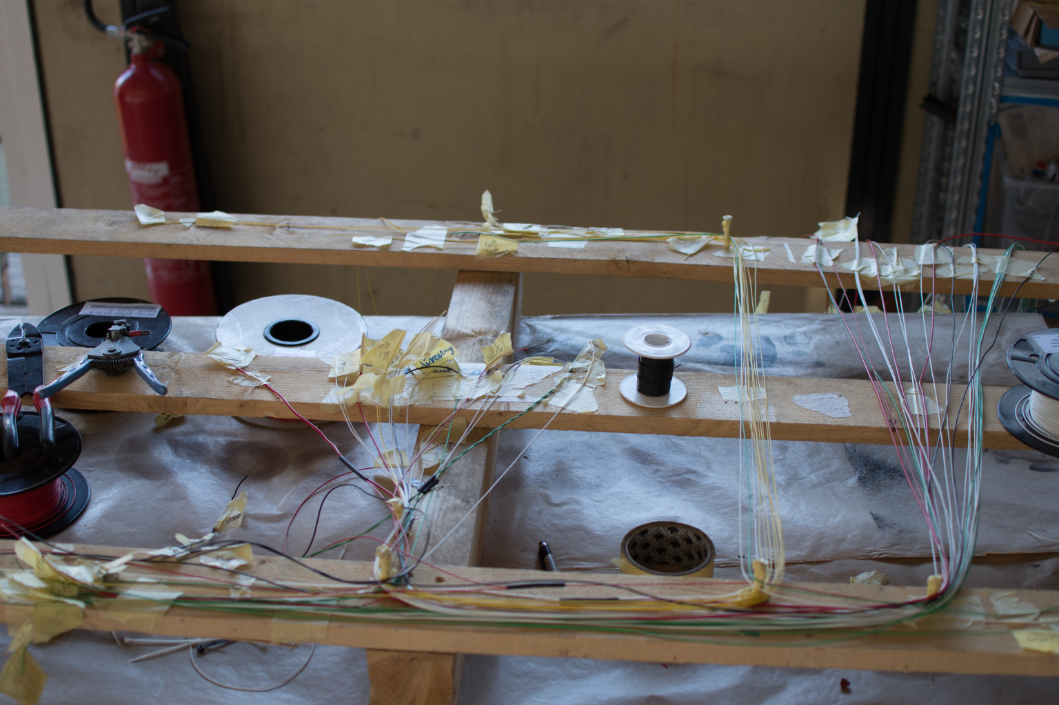

* We **twisted** our wire into **concentric layers** to have a better flexibility and a smaller section of the cable

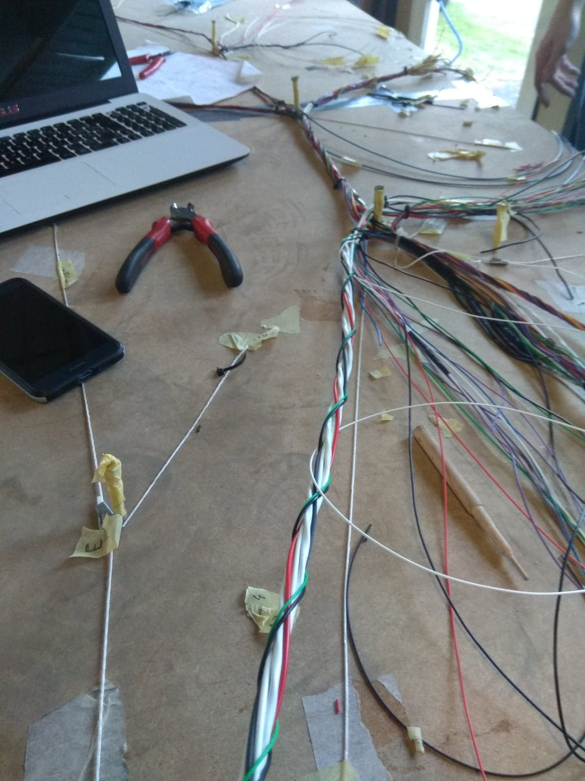

* We put all the Harness on the frame and **crimp** all of our **connectors** on it

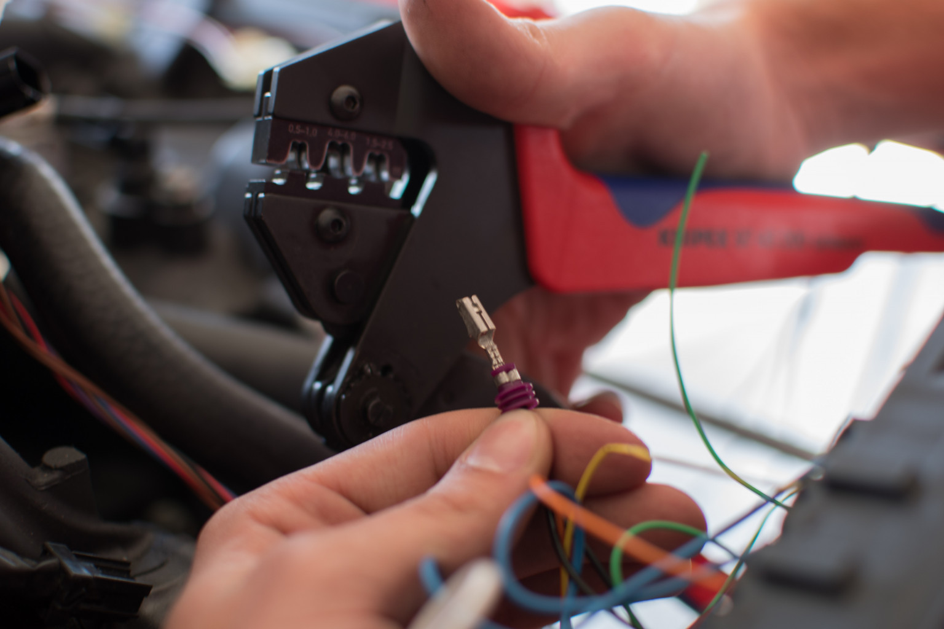

* Next, we **tested** all the functionality (engine start, gear change, dashboard display and control…)
* Finally, we take the harness out in order to **protect** it with a special **tap**. *\*Picture\**

***User friendly ?***

The dashboard: button which have to use during clutch activation are on the left side on vehicle, we have information like Water temp and battery voltage which allows our pilots to make quick choice during testing.

Connection with our ECU is easy and you can change a most of the car setting from it.

Connection with our data logger is also easy, you can make a hard connection or a wireless Bluetooth or wifi connection. All of the electrical information are in a printed folder and any member of the team can manage a little failure of the harness like a burned fuse.

***Data acquisition?***

